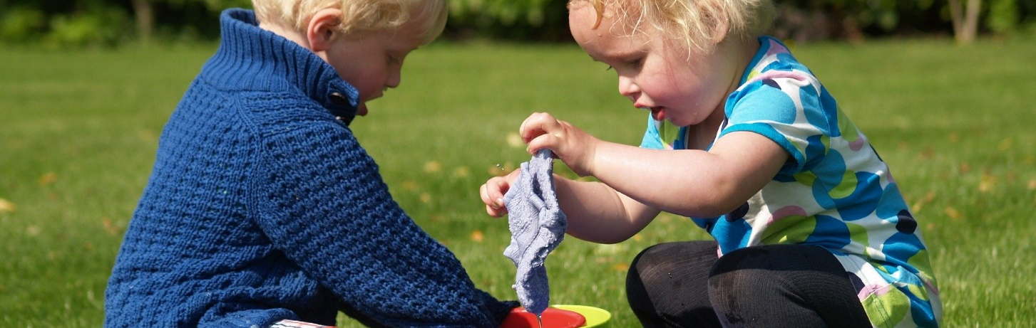

**Playgroup Educational work Plan**

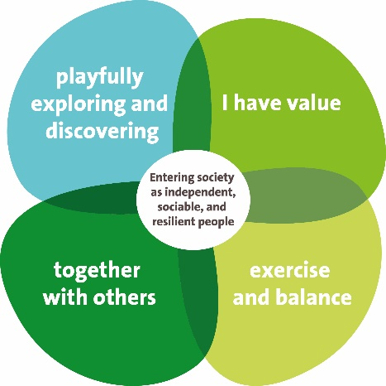**Happily growing together at the International Playgroup**

**Welcome to the International Playgroup!**

This educational work plan describes what a day at this location consists of and how the groups are assigned. It also provides important information about this location, such as opening hours, activities and what to do when your child is ill. This work plan is part of Bink’s educational policy. Our educational policy and more information about our educational flower can be found on Bink’s website.

**Contact information:**

Address: Rembrandtlaan 30A 1213 BH Hilversum

Telephone number: 035-647 2289

E-mail address: [s.galis@binkkinderopvang.nl](mailto:s.galis@binkkinderopvang.nl)

Location Manager: Silvia Galis

**Our location**

International Playgroup is located in the center of Hilversum in a beautiful old Dudok building with an adjoined playground. The International Primary School (Rembrandt location) and the out-of-school care Rembrandtplein is also located here. The International Playgroup consists of one group with a maximum of 16 children.

Inhoudsopgave

1 Ins and outs of the group 3

Intake and settling-in 3

Bringing and picking up 4

Opening hours 4

Declaring a child absent 4

Exchange and extra days 4

What do we do if a child becomes ill? 4

What do we do if a child has an accident? 5

2 A morning or afternoon at playgroup 6

A predictable daily routine 6

Eating and drinking 7

Celebrations at playgroup 7

Bodily care 7

Playfully discovering and exploring 8

3 Working on children’s development together 10

Mentor 10

Following a child’s development 10

Parental involvement 11

The transition to primary school 11

Working together with primary schools 12

4-Together with parents 13

The parent committee 13

Talking with parents 13

5-The group and staff members 15

The primary group 15

Spoken language 16

Who works for Bink? 16

**Attachment Code of conduct…………………………………………………………………………….19**

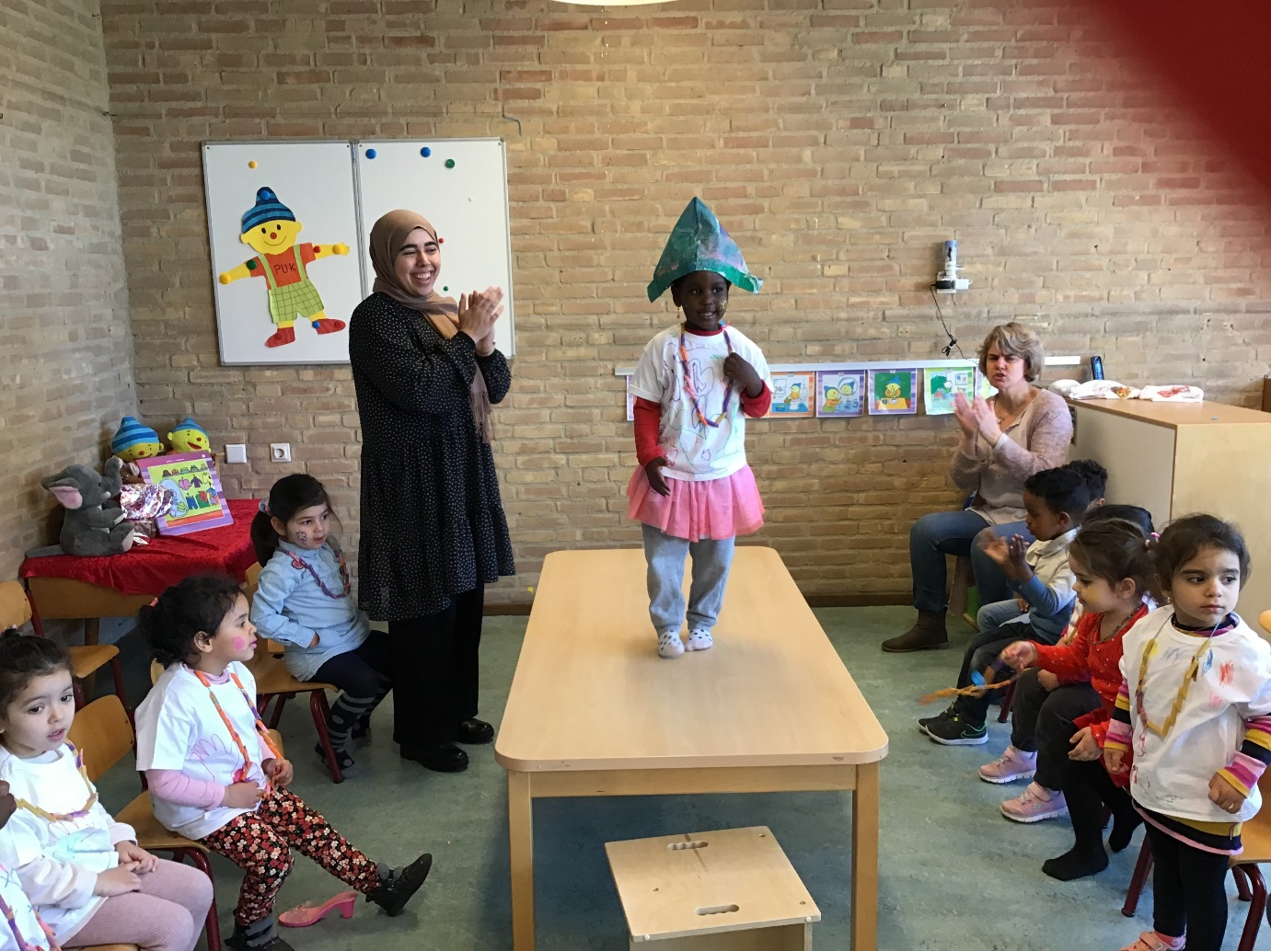

# 1 Ins and outs of the group

### Intake and settling-in

During the first meeting with parents, we take our time to get to know each other and exchange information. We make agreements with parents to ensure as smooth as possible a transition so that their child can feel secure with us. We also let the parents know who will be their child’s mentor. The mentor is a steady educational staff member to which parents can address their questions about their child’s wellbeing and development. The mentor makes the settling-in appointments with parents.

A settling in period lasts two weeks on average, giving parents and children the opportunity to adjust to their new situation. A steady educational staff member, preferably the mentor, guides the child in this process. Settling in is often custom work. A child is welcome to attend for a full morning from their first day, with adjustments made in accordance to child’s needs.

During settling-in, the mentor will closely observe how a child feels by, for example, staying as visible as possible and introducing him/her to other children. A mentor will say what he or she is doing and what is happening around them. The mentor will also mention the emotions that he or she sees the child is showing, allowing a child to feel understood. In this way, a child can get used to a new situation, feels safe, wants to play and pays attention to what is happening in the group.

We always give parents the opportunity, aside from bringing and picking up moments, to call and ask us how their child is doing. If needed, adjustments are made to the settling-in agreements. Once the settling period is over, we discuss how it went with the child’s parents.

Do you wish to learn more about what we find important when it comes to the settling-in of young children? Additional information on this topic can be found in the third chapter of our educational policy.

### Bringing and picking up

Children may be brought between 9 and 9.30 a.m.and be picked up at 12 noon.

If parents are occasionally unable to pick up their child themselves, we ask that they let us know in advance. This is possible via the parental portal. We do not allow a child to leave with someone else without parental permission.

### Opening hours

International Playgroup is open from Monday through Friday from 9 a.m. to 12 noon.

Our playgroups are open during school weeks. We are closed during school holidays and on certain other holidays during the year. The school holidays and closing days can be found on our website.

### Declaring a child absent

We ask parents to let us know if their child will not be coming. The educational staff members will also be able to let the other children of the group know that a child will not be coming that day. It is possible to declare a child absent via . Children’s development is best enhanced when a child is present on all of their agreed upon partial playgroup days. Should a child not be present for an extended period, we will contact parents to discuss.

### Exchange and extra days

Children come to playgroup on the same set days per week. The strictly accidental exchange of a partial day or the request of an additional partial day can only be arranged in agreement with an educational staff member. We determine if the request can be honored based on the size of the group and its composition. It is often the case that the requested partial day can only be considered and if possible approved on the day requested. This is because children are often declared absent on the same day that they are supposed to attend.

### What do we do if a child becomes ill?

If a child becomes ill at playgroup or comes in already ill, we first look at the general impression he or she gives us and at the child’s wellbeing. Does a child feel ill and does their behavior indicate that this is the case? Think of signs of pain, being clingier, crying a lot, a fever, vomiting, and diarrhea or not wanting to eat or drink. If a child is ill, he or she needs care and attention. At playgroup, a child cannot receive the amount of attention he or she needs, without affecting the other children in the group. This is an unpleasant situation for the ill child and the other children in the group. This is why we ask parents to come and pick up their child if they cannot participate in the daily activities. If the parents cannot be reached on their own telephone numbers, we call the emergency telephone number given in parental portal. We ask parents to please keep their own numbers or emergency numbers up to date via parental portal.

In case of illness of a child, Bink follows the illness policy as defined by the GGD. This information is also available on our website.

### What do we do if a child has an accident?

If a small accident occurs, our educational staff members are trained to provide first aid. If medical assistance is needed, we call the parent directly and consult with them about who will take the child to the doctor. In case of emergency, we call 112 and inform the parents as quickly as possible. The educational staff member stays with the child until a parent is present.

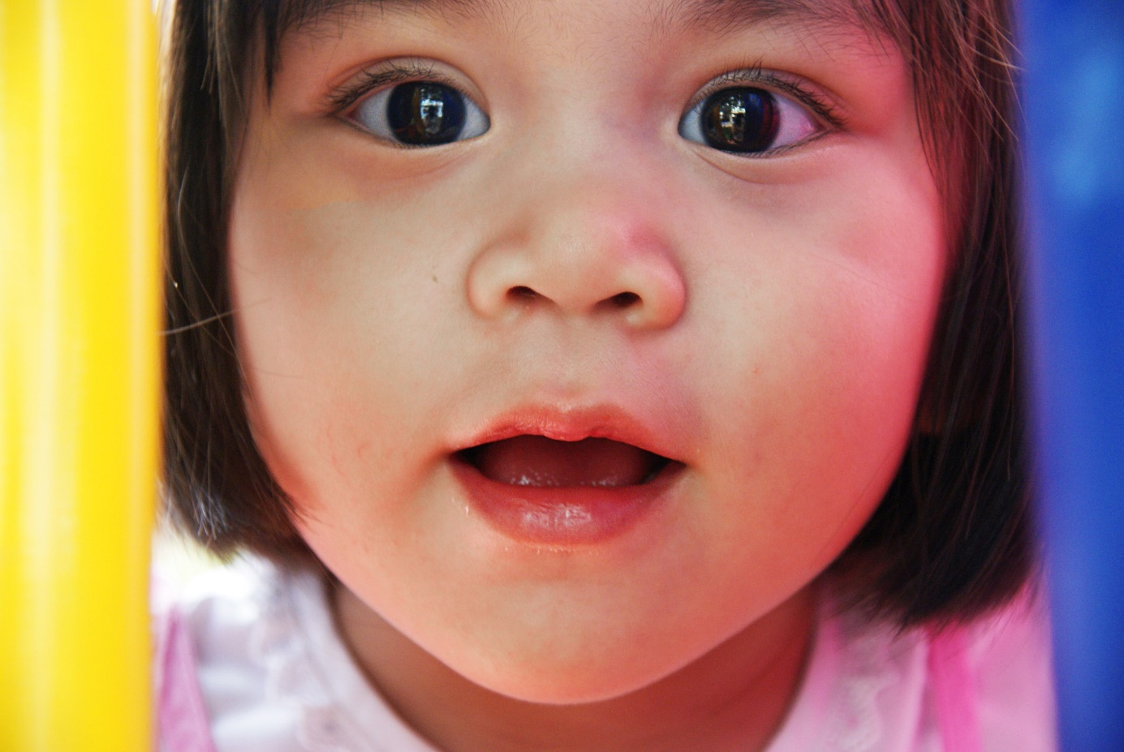

# 2 A morning or afternoon at playgroup

### A predictable daily routine

When a parent brings their child, an educational staff member gives them a warm welcome.

We have described what a typical day at playgroup looks like in our educational policy. More information is available in chapter three.

When a parent brings their child, they are given the opportunity to exchange important information concerning their child with the educational staff member. Saying goodbye is not always easy. We ask parents to do so where their child is currently playing. In this way, they remain more engaged in their play activity. If a child prefers to wave at the window, they may of course do so.

### Social Safety

Since moving from another country, adjusting to a new language, and adapting to a new environment can be a significant change for a child, this preschool maintains a set daily schedule to provide structure and a sense of security. The main language used at the preschool is English, so we ask parents to speak only English while at the IPG. Parents consciously choose this preschool because of its English-speaking environment.

However, it may still happen that a child has difficulty adjusting and does not feel safe. In such cases, we discuss with the parents the best way to handle this on an individualized basis, and it might be decided to pick up the child earlier in the morning.

If a child feels unheard due to language difficulties and cannot express themselves clearly, the educators seek alternative ways to ensure the child feels acknowledged. This can involve getting more input and information from the parents or using gestures and pictograms. This is a continuous focus and is reviewed annually.

* Would you like to learn more about our code of conduct as a supplement to the pedagogical policy? In the attachment (pages 19) of our pedagogical policy plan, you can read more about the guidelines that apply within our childcare center where another language is spoken.

### Eating and drinking

Parents give their children a healthy snack from home, such as fruit or vegetables, with perhaps a cracker or rice cake. In the morning or the afternoon, children eat a healthy snack and drink water.

We take the time to make eating together a cozy moment. We have conversations with the children and encourage them to talk to each other. Children sit in small groups with an educational staff member. They are also involved by helping to set or clear the table and are encouraged to do as much as possible themselves. They learn to make choices in what and how much they eat and drink.

We ask parents to let us know if a child is following a special diet or has food allergies so that we are able to keep this into consideration.

### Celebrations at playgroup

A child may celebrate his or her birthday at playgroup if he or she wishes to do so. The birthday child is the center of attention and can bring a treat to share. We ask parents to please bring a healthy treat. Children give a treat to the children of their own group. This is given right before or after snack time, so that teeth are not subjected to foods twice. If the treat is too much or not suitable because it does not follow our healthy nutrition policy, we may prefer to give it, or part of it, to take home.

Should you wish to learn more about what we find important concerning eating and drinking? More information on this topic is available in chapters two and three of our educational policy.

### Bodily care

A potty is, in principle, not used at playgroup. They are less hygienical than the toilet because they are more difficult to keep clean. Playgroups have special toddler toilets so that they can use them themselves. The educational staff member guides the child in their learning process to use the toilet on their own. Children still wearing nappies are changed once or more if seen as necessary.

### Playfully discovering and exploring

A child learns through play. At the IPG we work by focusing on development and using our own method: Learning through play. This is a program developed by our education experts.

We hold various daily activities in small groups. In this way, we are able to address a child’s individual needs and development. We very specifically address every developmental area through play: motor and sensory skills, cognitive and language skills, creative and visual skills and social-emotional skills. We repeatedly work for several weeks with a specific theme, such as “My body”, “Fall-Winter”, “Shopping for groceries” and “Family”. By offering children a variety of activities, we teach them to better understand and connect to the world around them. A theme lasts approximately six to eight weeks.

Aside from the daily activities, where busy and quiet activities alternate, we also incorporate free play and routine activities such as eating and tidying up. We keep a close eye on a child’s development. We adjust the activities we offer in accordance to how a child still can grow and further develop.

We make much use of the International Playgroup garden. The playgroup may also use the International Primary School’s gym two mornings a week (Tuesday and Friday). They sometimes use the Rembrandtplein out-of-school care kitchen to cook.  
* Would you like to learn more about our code of conduct as a supplement to the pedagogical policy? In the attachment (pages 19) of our pedagogical policy plan, you can read more about the guidelines that apply within our childcare center where another language is spoken.

*Different Family Situations*  
Days like Father’s Day and Mother’s Day are not always straightforward for every child and can sometimes bring about feelings of uncertainty or sadness. We talk with children about family and household structures, helping them understand that differences exist and that they are perfectly okay. Older children tend to have more questions and often share clear opinions. They also enjoy hearing how things are at others' homes. We guide these conversations when needed, highlighting differences in a way that allows every child to feel recognized. This approach helps us prevent unintended moments of sadness or discomfort.

**Playing indoors**

Playing indoors occurs mostly in the group’s primary location, and always under the supervision of an educational staff member. We always insure the right child-to-educational staff-member’s ratio, this also being the case when a child goes and plays in a different location.

The room is set up to invite children to play, with a variety of play and development activities offered. We have: counting games, dolls, cars, puzzles, building materials, books, blocks, etc. We also have a theme table in the group where theme-relevant books and materials are presented. Other play materials are available in rooms, which we use for different activities, such as a sand (or water) table. The room has well defined play areas. By creating defined play corners, children are able to find their way on their own and can easily play in small groups without disturbing each other’s play activity.

When playing in another room, an educational staff member supervises the International Playgroup’s children. This is not possible on own initiative. Free play takes place in their own group.

**In the garden**

Playing indoors is different from playing outdoors. The outdoor area again offers different opportunities to go and explore. Children discover their physical capabilities and explore what they can do with stones, sticks, water and sand. If children come up with their own games, we assess the level of risk involved and do not easily interfere. Children learn by falling and standing up again.

**Our outdoor play area**

The International Playgroup has a surrounding garden with a lot of room to bicycle, play hide and seek and run around. There is a swing, a water fountain, an outdoor kitchen, a climbing jungle-gym with a slide and a sand box.

When the sun begins to shine more often, large cloths are hung above the picnic tables and the sand box to provide sufficient shade.

**Excursions in the neighborhood**

On small excursions (such as for example a walk around the school building) we follow the excursions protocol. We go only if the number of children can be supervised by the necessary staff guidance and with parental permission. We use a walking rope that children hold on to and make agreements with them about how we should walk together. The children and staff members also wear Bink vests.

For larger excursions, such as a visit to the library, a playground or a petting zoo, we ask that one parent per child accompanies us.

Playfully discovering and exploring is one of our four educational principles. Additional information on this topic is available in our educational policy.  
* Would you like to learn more about our code of conduct as a supplement to the pedagogical policy? In the attachment (pages 19) of our pedagogical policy plan, you can read more about the guidelines that apply within our childcare center where another language is spoken.

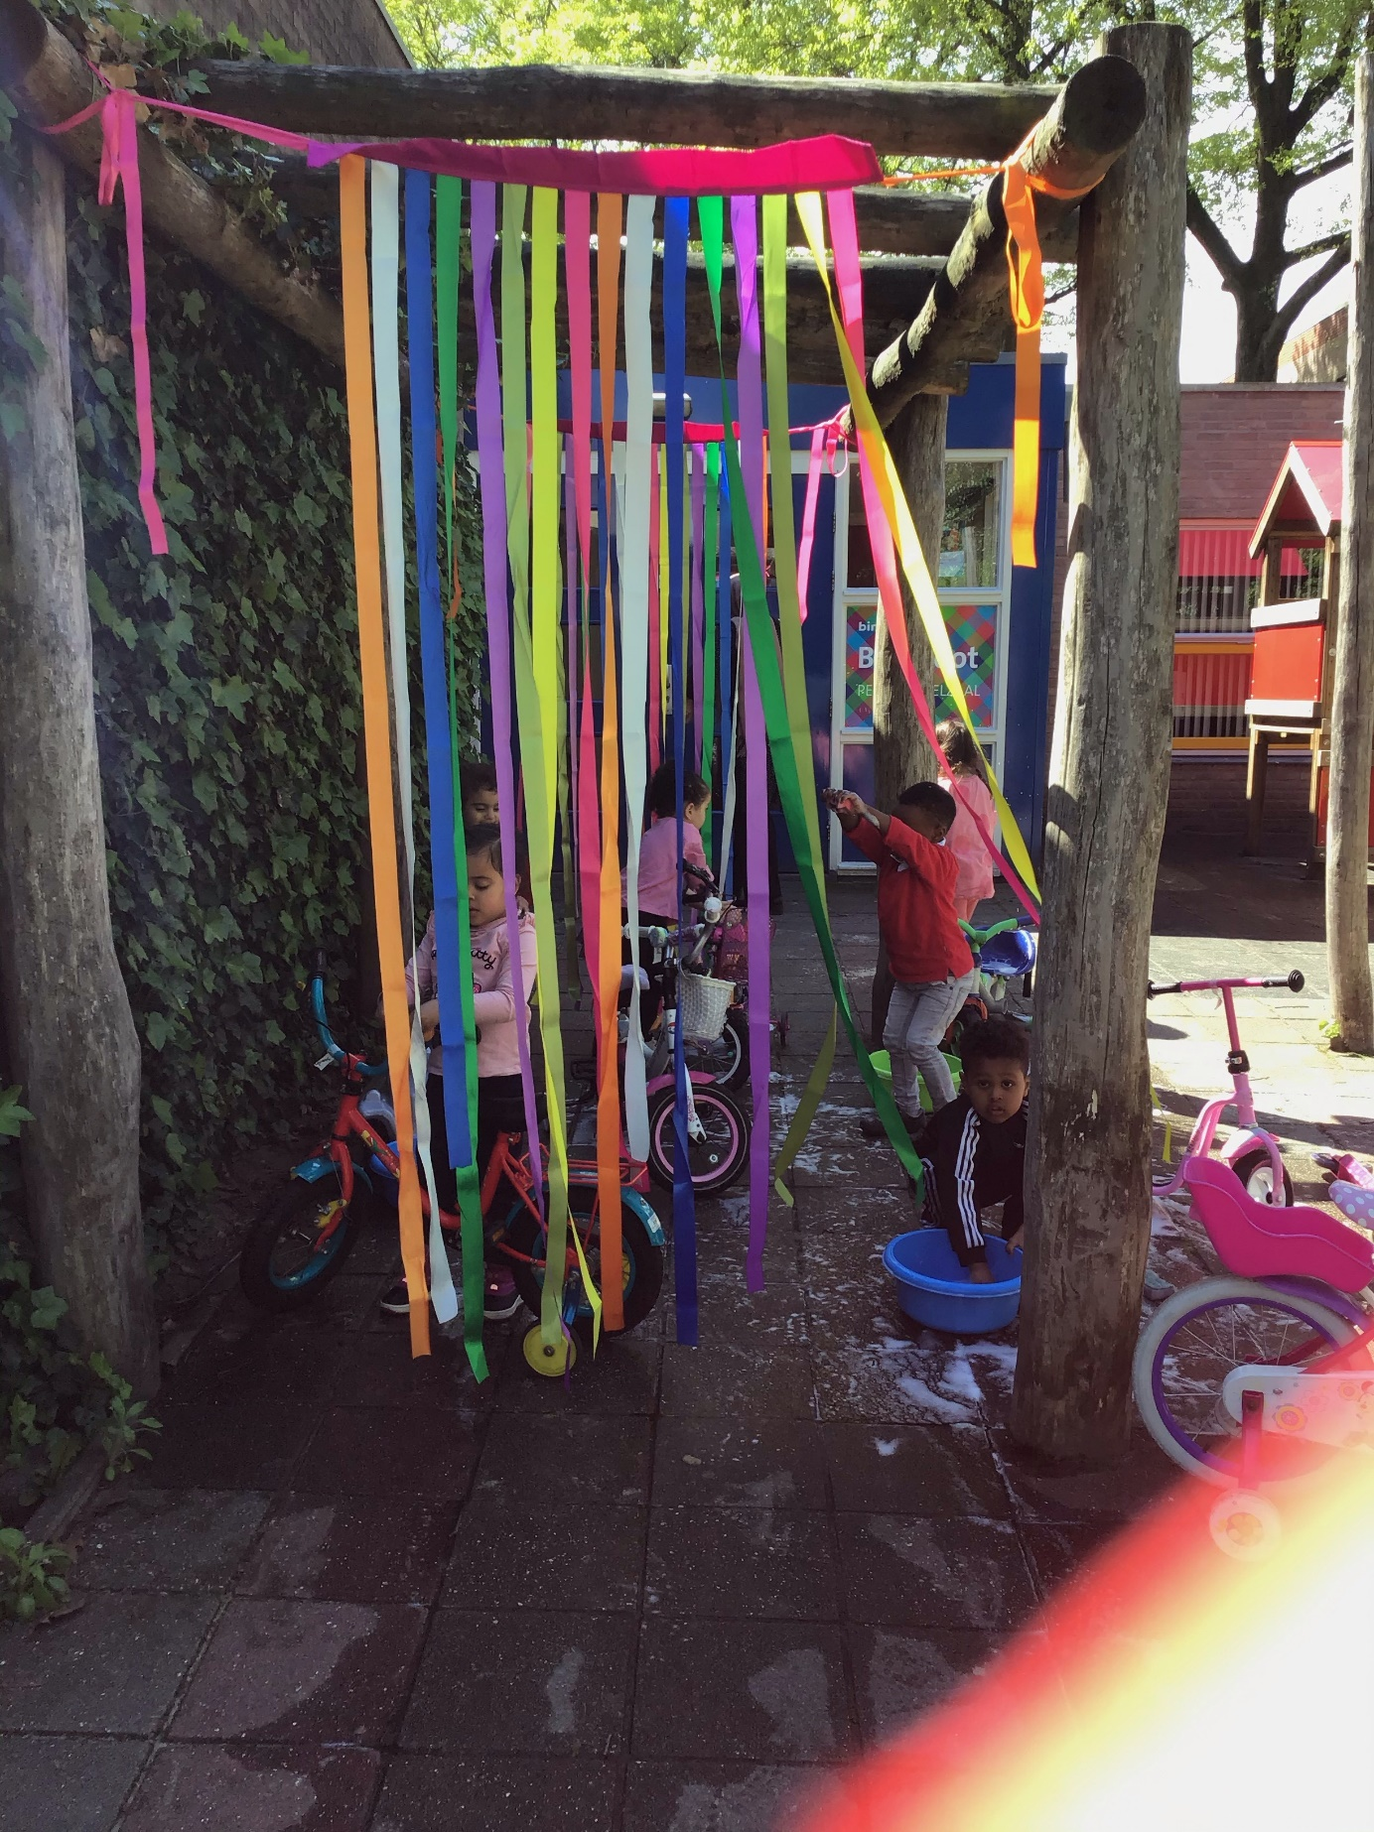

# 3 Working on children’s development together

We closely follow a child’s development with much attention and often speak with parents. We share information about a child’s well-being and experiences. We also communicate with parents via the parental portal. Parents receive general Bink wide, as well as location-specific, newsletters.

### Mentor

All educational staff members of a group are responsible for the care and guidance of all children. Children have a steady educational staff member as their mentor. Parents and child meet the mentor during their first introductory intake appointment. The mentor is an educational staff member from the child’s own group that he or she often sees.

Would you like more information about what you can expect from a mentor? Additional information on this topic is available in chapter four of our educational policy.

### Following a child’s development

We use our development tracker system “Growing Together” to follow a child’s development, from the first meeting to saying farewell.

A mentor observes a child twice a year in different situations. We invite parents to come in for a conference after each observation and review the observation report together.

If parents or a mentor wishes to speak about a child’s development at another given time, an appointment is arranged for a meeting.

We work in a result-oriented fashion, meaning that we use the information gained during observations of a child’s development to offer well-suited activities. These activities meet a child’s needs and encourage developmental growth.

At times, a child will show a particular behavior or have another reason for needing extra attention and guidance. Parents may also be concerned about their child. We are able to offer parents our support or help them find their way to more specialized assistance.

Bink also works in conjunction with Trompendaal and Sherpa. The specialized staff members from these organizations are able to provide extra guidance or support for the educational staff members and your child. Specialized staff members observe a child in the group and give educational staff member’s tips to guide the child. It is also possible that a specialized staff members guides the child personally. This will only take place after parents have been informed and given the permission to do so.

We have written about our joint working efforts towards children’s development. This topic is addressed in chapter four.

### Parental involvement

“Happily growing together” also means together with parents. The before-school-education aims to encourage a child’s development at the playgroup and at home. Children are best prepared for primary school by also working on their development at home.

We collaborate with parents by engaging in conversations about the children and by organizing gatherings where parents, staff, and children can get to know each other better and build connections.

At the beginning of a new theme, parents receive a detailed newsletter with information along with tips for addressing the theme at home.

The activities focus on different areas of development and on playing together. The areas of development that are covered include language development, social-emotional development, motor skills, and early math stimulation.

### The transition to primary school

When a child turns four, they transition to primary school. A child’s playgroup mentor invites parents for a final conference. All observations that have been made are reviewed are handed over to the parent as well as an overview report for the child’s chosen primary school. It is important for their teacher to know how a child has developed during their first years. We have good contact with our adjoined primary schools, and ask parental permission to send the overview report to the chosen school.

Should a child have an indication from the playgroup, we find it important to hand over the overview report in person during an appointment with the teacher, for example in the case of special developmental observations or if there is concern about a child’s development. This we call a warm handover. This of course only takes place with written parental permission or their participation.

In this way, a teacher can ensure good follow through in a child’s development. If the teacher has any questions, it is possible to exchange information with the mentor, but only with parental permission.

### Working together with primary schools

The children from the IPG (International Playgroup) attend various schools in Hilversum. These schools do not all use the same early childhood programs, but activities and themes generally align.

Since the IPG playgroup is housed in the building of IPS Rembrandtplein, there is close cooperation with this school.

Before the summer holidays start, there is a viewing moment at the IPS school for the children who will start primary school after the summer holidays to ensure a smooth transition to the IPS primary school.

Because the staff of the playgroup and the teacher of the IPS know each other, information is regularly exchanged. Together, they ensure a warm handover. For example, the IPS has a similar morning routine that includes a circle time, offers much freedom for the child to explore which activity they want to participate in, and uses the same "clean up, clean up" song to encourage children to help with tidying up.  
Additionally, we have several similar themes such as: exploring and wondering, sharing, we do it together, moving and in balance, I am allowed to be, exploring different forms of art.

For other schools, observation forms are forwarded to the school with the parents' permission. In case of concerns, telephone contact is made with the school.

Annual meetings are held with the municipality, involving playgroups and primary schools. During these meetings, we discuss, for example, how the handover process is going or how we can strengthen collaboration with parents.

In chapter four of our pedagogical policy plan, you can read about the transition to after-school care.

* Would you like to learn more about our code of conduct as a supplement to the pedagogical policy? In the attachment (pages 19) of our pedagogical policy plan, you can read more about the guidelines that apply within our childcare center where another language is spoken.

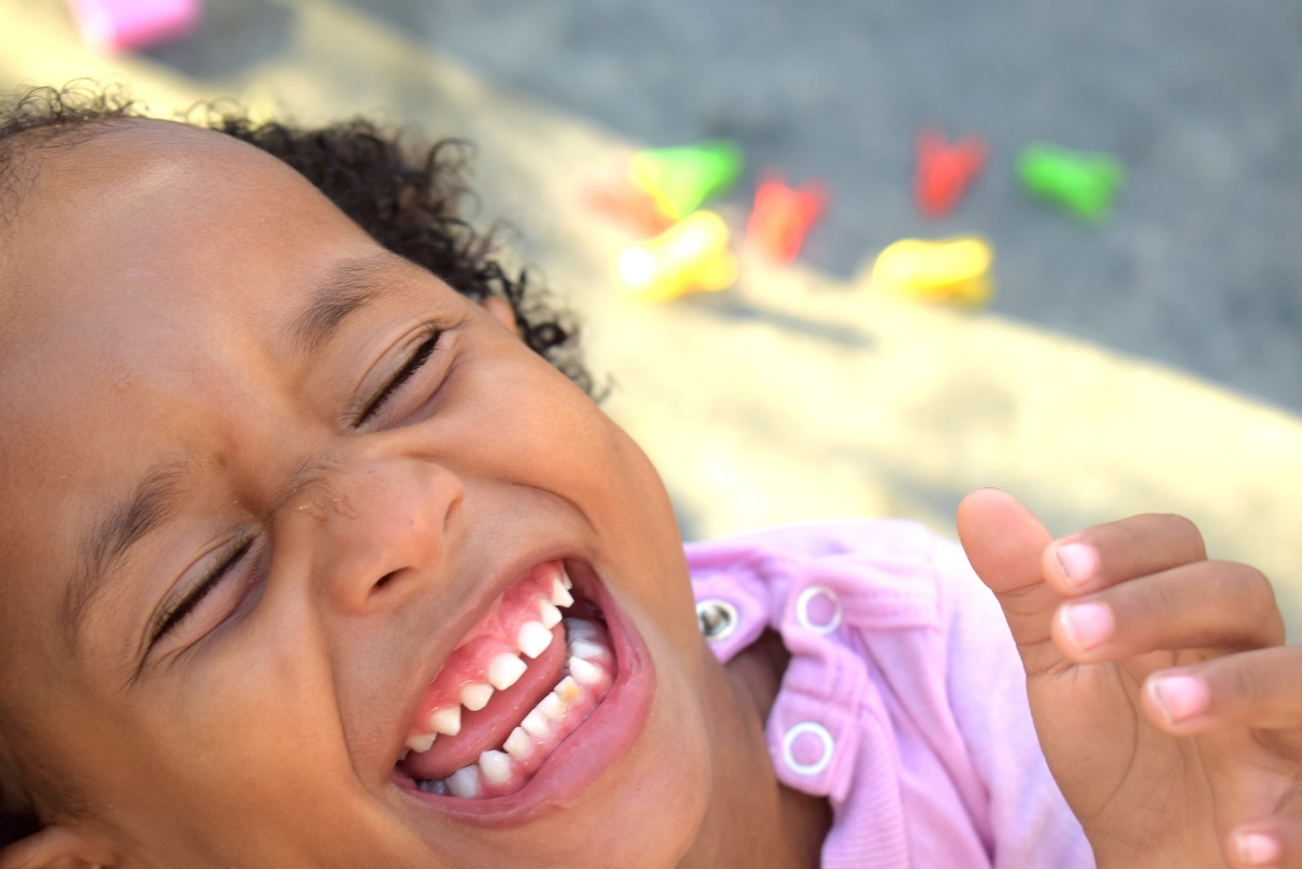

# 4-Together with parents

### The parent committee

The committee consists of several parents as representatives who represent the interests of all parents of the location. The parent committee is involved and advises on matters concerning the playgroup. Topics, such as for example the health and safety policy, are discussed and reviewed with the parent committee on a yearly basis. They also help organize parent evenings and other festivities. The tasks and authority of the parent committee are defined in the parent committee settlement agreement. The parent committee meets at least four times a year and consults with the location manager.

Every location with room for fifty children or more strives to have a parent committee. If a location does not have room for fifty children or if there is no parent committee, an alternative parent consultation is used.

### Talking with parents

We strive to provide the highest quality of care and to continuously improve where we can. If parents are not satisfied about a particular aspect, we first meet with them to discuss this and come to a resolution together. If it is not possible to resolve it in this manner we follow the complaint procedures as defined on Bink’s website.

* Would you like to learn more about our code of conduct as a supplement to the pedagogical policy? In the attachment (pages 19) of our pedagogical policy plan, you can read more about the guidelines that apply within our childcare center where another language is spoken.

*Childcare arbitration committee*

Should parents not be satisfied with the handling of a complaint and are unable to resolve it with the direction, they can present their complaint to the childcare complaints office located in The Hague, or notify the Childcare Arbitration committee. Additional information can also be found on Bink’s website.

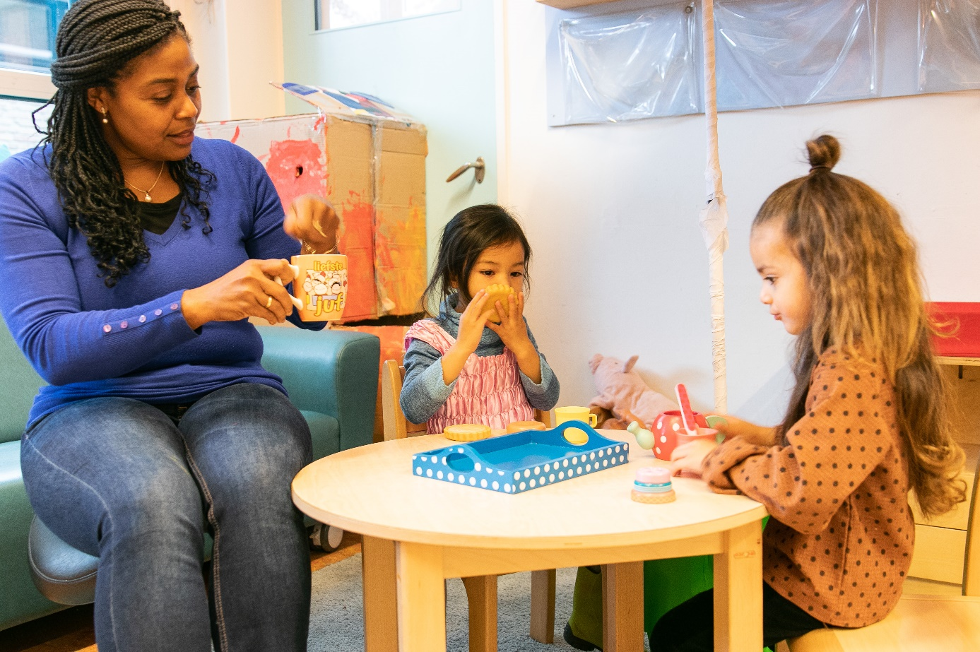

# 5-The group and staff members

### The primary group

A child’s steady group is the primary group with a maximum of sixteen children. This primary group has its own name, location and two steady educational staff members. Some locations allow toddlers to play, or have a special activity, in another room.

We ensure that there are always enough steady staff members present for the number of children in the group. At this moment, we are not using the option to assign another familiar face as a permanent face.

The primary group is a familiar location, where the children can feel at ease. They know their way around and the children can take play materials and tidy-up on their own.

|  |  |  |  |
| --- | --- | --- | --- |
| **Name of primary group** | **Age category** | **Maximum number of children** | **Number of educational staff members** |
| Playgroup | 2-4 years | 16 | 2 |
|  |  |  |  |

Every primary group has its own steady educational staff members; at least one staff member per eight children present. They know the children and ensure that the right care is given. All of a child’s important information is registered in the parental portal, such as, for example, information about food and allergies.

The space is arranged according to Bink's setup policy and the guidelines of the preschool program Uk & Puk.

Below is the exact arrangement of the primary groups.

We also use parental portal to inform parents of (long-term) absences of one of the steady educational staff members. The substitute’s name is also mentioned. In this way, parents remain informed of any changes in the regular schedule.

### Spoken language

The International Playgroup targets expat families and all other parents who wish to have their children learn and speak the English language at playgroup to be prepared for an international school and a “globally oriented life”. This is why the International Playgroups spoken language is English.

We encourage the children to develop their English language skills. For some of the children attending International Playgroup, English will be their second or third language. For others, their mother tongue. This is why we speak English only with International Playgroup children and parents. Our educational program, books and other developmental materials and activities are adjusted for the English language. Our International Playgroup is comparable to our regular daycare, but without mandatory VVE.

* Would you like to learn more about our code of conduct as a supplement to the pedagogical policy? In the attachment (pages 19) of our pedagogical policy plan, you can read more about the guidelines that apply within our childcare center where another language is spoken.

### Who works for Bink?

*Staff members, training and education*

Bink finds the sustainable development of its staff members important. Annually, we create a training plan based on our policy for professional development. This plan includes various training sessions, courses, and workshops that enhance the expertise of the staff for the purpose of improving pedagogical quality and/or personal development.

All staff members at the preschool hold a recognized Early Childhood Education (VVE) certificate or are currently undergoing the training. Additionally, they participate in the recertification program, ensuring continuous education.

With one exception: the International Playgroup (IPG). At the IPG, staff members do not have an VVE certificate. The International Playgroup is comparable to our regular childcare services, without VVE- obligations.  
* Would you like to learn more about our code of conduct as a supplement to the pedagogical policy? In the attachment (pages 19) of our pedagogical policy plan, you can read more about the guidelines that apply within our childcare center where another language is spoken.

In addition, educational staff members experience sustainable development by means of coaching-on-the-job from an educational coach and policy officer. The educational coach supports educational staff members in their educational interactions by, among other things, on-the-job coaching, visual coaching and workshops. The educational coach focuses strengthening the educational staff members’ interactive skills and result-oriented work.

We follow new knowledge and insights from different disciplines (education, psychology, education) closely, making adjustments as much as possible in our educational approach. The pedagogues also work closely with the site manager to maintain and enhance the pedagogical quality at the location.

*Educational staff members in training: The Bink Academy*

Students of different levels and educational background work for Bink. The majority is following an education to receive a diploma that qualifies them to work in childcare. This can be a BOL (professional learning education) or a BBL (professional guidance education).

The BOL student is always scheduled as extra staff. The acquired competencies determine what the student can do independently in the group under the supervision and responsibility of a certified colleague. The educational institution, the work supervisor in the group and the work placement trainers are involved. The tasks and responsibilities assigned to a student are determined together.

The BBL student always starts as extra staff in a group. In addition to level 3, we also have BBL students who follow level 4 training (KOP – Klas). These students already have a level

3 diploma/certificate and are authorized to work within childcare. These employees may be deployed in a VE-group as long as they meet the language requirement and they have a VVE-certificate or they are following the internal UK and Puk training. The level 4 BBL students are always deployed alongside a pedagogical staff member who VVE-certified.

As an additional educational component, Bink offers a Gordon-Communication training. Educational staff members are also trained in regards to child abuse and domestic violence, and receive a First-Aid training from the Red Cross. Students are also coached using visual feedback training methods.

At times, interns will follow a social or introductory internship at Bink. They are never left alone with children and are always under the supervision of a certified staff member. At a daycare or a playgroup, interns are able to:

* play indoors or outdoors with children
* Read children a story
* Play games
* Assist during snack time under the supervision of an educational staff member
* help with group and household chores

The International Playgroup does not currently have any interns or educational support student.

*Volunteers*

Aside from interns, volunteers at times come to work. These volunteers help with daily activities within the group and are thereby involved with the children, by, for example, reading them a story or initiating an activity. You can find out how a volunteer is allowed to work under the supervision of educational staff members in Bink’s volunteer policy. In addition, every volunteer signs a contract in which tasks and responsibilities are clearly defined. Volunteers are always extra in a group.

There are no volunteers working at International Playgroup at this time.

Attachment Code of conduct

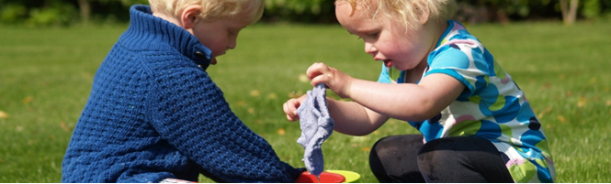

1. Foreign-language childcare

IPG offers foreign-language childcare under Article 1.55 paragraph 21 of the Childcare Act, i.e. day care where a language other than Dutch is spoken because the origin of the children necessitates it in specific circumstances. This code of conduct describes how we deal with this within IPG.

1. Spoken language

The International Playgroup targets expat families and all other parents who wish to have their children learn and speak the English language at playgroup to be prepared for an international school and a “globally oriented life”. This is why the International Playgroups spoken language is English.

We encourage the children to develop their English language skills. For some of the children attending International Playgroup, English will be their second or third language. For others, their mother tongue. This is why we speak English only with International Playgroup children and parents. Our educational program, books and other developmental materials and activities are adjusted for the English language. Our International Playgroup is comparable to our regular daycare, but without mandatory VVE.

1. Pedagogical principles

Our pedagogical policy has four principles. These principles are not separate from each other but reinforce each other. Offering childcare in a non-Dutch language is in line with our pedagogical principles as described in our pedagogical policy. 

**3.1** **I have value**

Social Safety

Since moving from another country, adjusting to a new language, and adapting to a new environment can be a significant change for a child, this preschool maintains a set daily schedule to provide structure and a sense of security. The main language used at the preschool is English, so we ask parents to speak only English while at the IPG. Parents consciously choose this preschool because of its English-speaking environment.

However, it may still happen that a child has difficulty adjusting and does not feel safe. In such cases, we discuss with the parents the best way to handle this on an individualized basis, and it might be decided to pick up the child earlier in the morning.

If a child feels unheard due to language difficulties and cannot express themselves clearly, the educators seek alternative ways to ensure the child feels acknowledged. This can involve getting more input and information from the parents or using gestures and pictograms. This is a continuous focus and is reviewed annually.

**3.2** **Playfully exploring and discovering**

A child learns through play. We work by focusing on development and using our own method: Learning through play. This is a program developed by our education experts.

We hold various daily activities in small groups. In this way, we are able to address a child’s individual needs and development. We very specifically address every developmental area through play: motor and sensory skills, cognitive and language skills, creative and visual skills and social-emotional skills. We repeatedly work for several weeks with a specific theme, such as “My body”, “Fall-Winter”, “Shopping for groceries” and “Family”. By offering children a variety of activities, we teach them to better understand and connect to the world around them. A theme lasts approximately six to eight weeks.

Aside from the daily activities, where busy and quiet activities alternate, we also incorporate free play and routine activities such as eating and tidying up. We keep a close eye on a child’s development. We adjust the activities we offer in accordance to how a child still can grow and further develop.

**3.3** **Together with others**

Different cultures and backgrounds come together in the group. Think of different types of food, customs and rituals around parties and birthdays. We actively involve parents in this and connect with different experiences of children. In this way we learn to understand, respect and appreciate each other.

Parental involvement

“Happily growing together” also means together with parents. The before-school-education aims to encourage a child’s development at the playgroup and at home. Children are best prepared for primary school by also working on their development at home.

We collaborate with parents by engaging in conversations about the children and by organizing gatherings where parents, staff, and children can get to know each other better and build connections.

At the beginning of a new theme, parents receive a detailed newsletter with information along with tips for addressing the theme at home.

The activities focus on different areas of development and on playing together. The areas of development that are covered include language development, social-emotional development, motor skills, and early math stimulation.

Working together with primary schools

The children from the IPG (International Playgroup) attend various schools in Hilversum. These schools do not all use the same early childhood programs, but activities and themes generally align.

Since the IPG playgroup is housed in the building of IPS Rembrandtplein, there is close cooperation with this school. IPS Rembrandtplein has English as spoken language, just like IPG.

**3.4** **Exercise and balance**

Growing and learning takes a lot of energy, learning two languages is an extra challenge. Lots of varied exercise and healthy food contribute to children feeling good, having more energy and motivation to learn new words and phrases in a second language (English).

1. Language requirement for a non-Dutch-language childcare professional

A professional at the non-Dutch-speaking childcare has a certificate or diploma showing that he or she has mastered the English language for the sub-skills of conversations, reading, listening and speaking at least level B2 of the Common European Framework of Reference for Languages. The supervisor of Bink checks whether the language level of the professional is sufficient.    
     
If the regular employees are absent, substitute staff will be deployed who also meets the language requirement (level B2 of the Common European Framework of Reference for Languages).